Module Design Document
For
Controller Polarity – Brushless Systems
FDD #25C

VERSION: 2.0
DATE: 18-Mar-2015

Prepared By:
EPS Software Group,
Nexteer Automotive,
Saginaw, MI, USA
Location: The official version of this document is stored in the Nexteer Configuration Management System.

Revision History

Sl. No. | Description | Author | Version | Date
1 | Initial Version | Michael Story | 1.0 | 06-Mar-2015
2 | Added design difference statement | Michael Story | 1.1 | 18-Mar-2015
3 | Added design difference statement for Pim | Michael Story | 2.0 | 18-Mar-2015

Table of Contents
1 Abbrevations And Acronyms 5
2 References 6
3 Controller Polarity & High-Level Description 7
4 Design details of software module 8
4.1 Graphical representation of Controller Polarity 8
4.2 Data Flow Diagram 8
4.2.1 Module level DFD 8
4.2.2 Sub-Module level DFD 8
4.3 COMPONENT FLOW DIAGRAM 9
5 Variable Data Dictionary 10
5.1 User defined typedef definition/declaration 10
5.2 Variable definition for enumerated types 10
6 Constant Data Dictionary 11
6.1 Program(fixed) Constants 11
6.1.1 Embedded Constants 11
6.1.1.1 Local 11
6.1.1.2 Global 11
6.1.2 Module specific Lookup Tables Constants 12
7 Software Module Implementation 13
7.1 Sub-Module Functions 13
7.2 Initialization Functions 13
7.2.1 Init: Polarity_Init 13
7.2.1.1 Design Rationale 13
7.2.1.2 Module Outputs 13
7.2.1.3 Module Internal 13
7.3 PERIODIC FUNCTIONS 13
7.3.1 Per: <ModuleName>_Per<n> 13
7.3.1.1 Design Rationale 13
7.3.1.2 Store Module Inputs to Local copies 13
7.3.1.3 (Processing of function)……… 13
7.3.1.4 Store Local copy of outputs into Module Outputs 13
7.4 Interrupt Functions 14
7.4.1 Isr: <ModuleName>_Isr<n)> 14
7.4.1.1 Design Rationale 14
7.4.1.2 (Processing of the ISR function)….. 14
7.5 Serial Communication Functions 15
7.5.1 SComm: Polarity_SCom_ReadPolarity 15
7.5.1.1 Design Rationale 15
7.5.1.2 Store Module Inputs to Local copies 15
7.5.1.3 (Processing of function)……… 15
7.5.1.4 Store Local copy of outputs into Module Outputs 15
7.5.2 SComm: Polarity_SCom_SetPolarity 15
7.5.2.1 Design Rationale 15
7.5.2.2 Store Module Inputs to Local copies 15
7.5.2.3 (Processing of function)……… 15
7.5.2.4 Store Local copy of outputs into Module Outputs 15
7.6 Local Function/Macro Definitions 15
7.6.1 GetPolarity() 15
7.6.1.1 Description 16
7.7 GLObAL Function/Macro Definitions 16
7.8 TRANSIENT FUNCTIONS 16
7.8.1 Per: <ModuleName>_Trns<n> 16
8 Known Limitations With Design 17
9 UNIT TEST CONSIDERATION 18
10 Appendix 19

Abbrevations And Acronyms
Abbreviation | Description
DFD | Design functional diagram
MDD | Module design Document

References
This section lists the title & version of all the documents that are referred for development of this document
Sr. No. | Title | Version
1 | Controller Polarity – Brushless Systems FDD #25C0 | 01.00.00

Controller Polarity & High-Level Description
This module implements the polarity assignments for the EPS systems to allow for various configurations of input and output signals for proper alignment.

*Module default output does not match design due to incompatability with existing input components.

** Rte_Pim_Polarity_Cnt_Str() does not match design due to incomaptability with existing components.

Design details of software module

Graphical representation of Controller Polarity
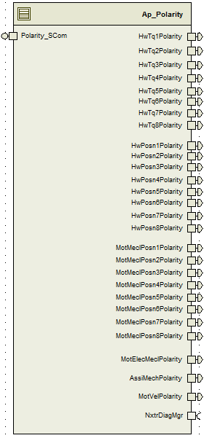

Data Flow Diagram
None

Module level DFD
None

Sub-Module level DFD
None

COMPONENT FLOW DIAGRAM
None

Variable Data Dictionary

User defined typedef definition/declaration

Typedef Name | Element Name | User Defined Type | Legal Range  (min) | Legal Range  (max)

Variable definition for enumerated types
Enum Name | Element Name | Value

Constant Data Dictionary

Program(fixed) Constants

Embedded Constants

Local
Constant Name | Resolution | Units | Value
D_HWTRQPOL1_CNT_U32 | 1 | Counts | 0x0000001
D_HWTRQPOL2_CNT_U32 | 1 | Counts | 0x0000002
D_HWTRQPOL3_CNT_U32 | 1 | Counts | 0x0000004
D_HWTRQPOL4_CNT_U32 | 1 | Counts | 0x0000008
D_HWTRQPOL5_CNT_U32 | 1 | Counts | 0x0000010
D_HWTRQPOL6_CNT_U32 | 1 | Counts | 0x0000020
D_HWTRQPOL7_CNT_U32 | 1 | Counts | 0x0000040
D_HWTRQPOL8_CNT_U32 | 1 | Counts | 0x0000080
D_HWPOSPOL1_CNT_U32 | 1 | Counts | 0x0000100
D_HWPOSPOL2_CNT_U32 | 1 | Counts | 0x0000200
D_HWPOSPOL3_CNT_U32 | 1 | Counts | 0x0000400
D_HWPOSPOL4_CNT_U32 | 1 | Counts | 0x0000800
D_HWPOSPOL5_CNT_U32 | 1 | Counts | 0x0001000
D_HWPOSPOL6_CNT_U32 | 1 | Counts | 0x0002000
D_HWPOSPOL7_CNT_U32 | 1 | Counts | 0x0004000
D_HWPOSPOL8_CNT_U32 | 1 | Counts | 0x0008000
D_MOTMEDPOL1_CNT_U32 | 1 | Counts | 0x0010000
D_MOTMEDPOL2_CNT_U32 | 1 | Counts | 0x0020000
D_MOTMEDPOL3_CNT_U32 | 1 | Counts | 0x0040000
D_MOTMEDPOL4_CNT_U32 | 1 | Counts | 0x0080000
D_MOTMEDPOL5_CNT_U32 | 1 | Counts | 0x0100000
D_MOTMEDPOL6_CNT_U32 | 1 | Counts | 0x0200000
D_MOTMEDPOL7_CNT_U32 | 1 | Counts | 0x0400000
D_MOTMEDPOL8_CNT_U32 | 1 | Counts | 0x0800000
D_MOTELECPOL_CNT_U32 | 1 | Counts | 0x1000000
D_ASSMECHPOL_CNT_U32 | 1 | Counts | 0x2000000
D_MotVelPOL_CNT_U32 | 1 | Counts | 0x4000000

Global
<This section lists the global constants used by the module. For details on global constants, refer to the Data Dictionary for the application>
Constant Name
D_ONE_CNT_S8
D_NEGONE_CNT_S8

Module specific Lookup Tables Constants

Constant Name | Resolution | Value | Software Segment
None

Software Module Implementation

Sub-Module Functions

Initialization Functions

Init: Polarity_Init

Design Rationale
This function provides a +1 or -1 output signal to various points intended to be used as a multiplier to change the sign of signals.

Module Outputs
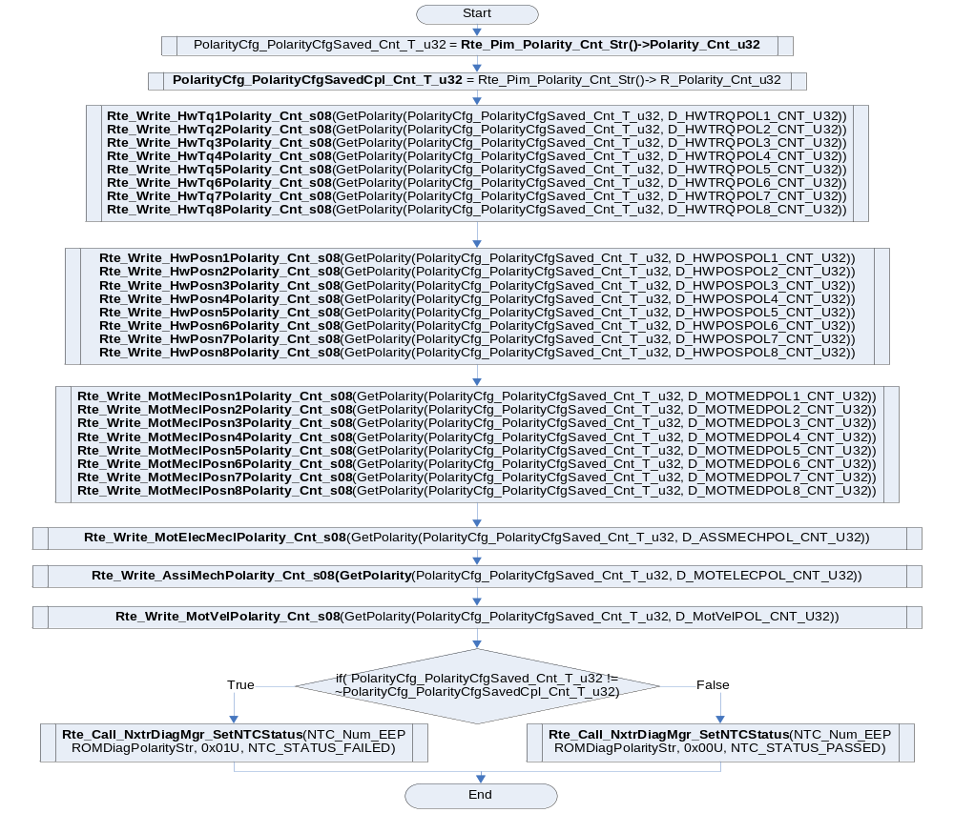

Module Internal
None

PERIODIC FUNCTIONS
None

Per: <ModuleName>_Per<n>

Design Rationale
None

Store Module Inputs to Local copies
None

(Processing of function)………
None

Store Local copy of outputs into Module Outputs
None

Interrupt Functions
None

Isr: <ModuleName>_Isr<n)>
None

Design Rationale
None

(Processing of the ISR function)…..
None

Serial Communication Functions

SComm: Polarity_SCom_ReadPolarity

Design Rationale
None

Store Module Inputs to Local copies

(Processing of function)………
*PolarityCfg_PolarityCfgSaved_Cnt_T_u32 = PolarityCfg_PolarityCfgSaved_Cnt_u32

Store Local copy of outputs into Module Outputs
None

SComm: Polarity_SCom_SetPolarity

Design Rationale
None

Store Module Inputs to Local copies
None

(Processing of function)………
Rte_Pim_Polarity_Cnt_Str()->PolarityCfg_PolarityCfgSaved_Cnt_u32 = PolarityCfg_PolarityCfgSaved_Cnt_T_u32
Rte_Pim_Polarity_Cnt_Str()->PolarityCfg_PolarityCfgSavedCpl_Cnt_u32 = ~PolarityCfg_PolarityCfgSaved_Cnt_T_u32

Store Local copy of outputs into Module Outputs

Local Function/Macro Definitions

GetPolarity()
Function Name | GetPolarity | Type | Min | Max
Arguments Passed | Polarity_Cnt_T_u32 | Uint8 | Full | Full
 | PolarityMask_Cnt_T_u32 | Uint8 | Full | Full
Return Value | Polarity_Cnt_T_s08 | sint8 | -1 | 1

Description
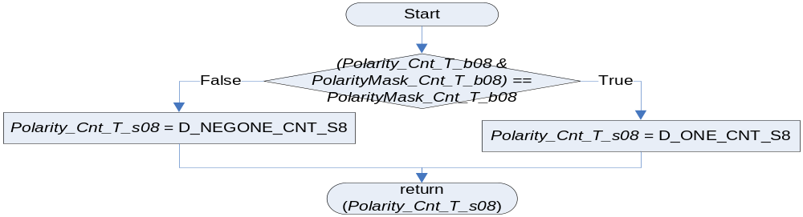

GLObAL Function/Macro Definitions
None

TRANSIENT FUNCTIONS
None

Per: <ModuleName>_Trns<n>
None

Known Limitations With Design
- Explanation of what should be and should not be mentioned in design rationale limitations

UNIT TEST CONSIDERATION

Appendix
<This section is for appendix>

